**Health & Safety Talk**

**Emergency Management**

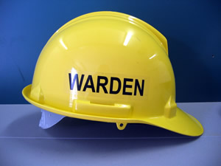

Emergency management plans can cover a number of different emergencies which may occur in the workplace and are an essential part of any business.

**What can they cover?**

Fire Bomb Threat Personal Threat

Medical Emergency Chemical Spill Flooding

**What should be done?**

* When being inducted, ensure you familiarise yourself with the sites emergency management plan.
* Know your assembly area and where to gather in case of an emergency.
* Know who your fire / emergency wardens are (if any) and if you are a warden familiarise yourself with your designated role.
* Make sure you know where the emergency exits / doors are located throughout the facility.
* Under **no** circumstances should you re-enter the building once you have left, unless safe and ordered to do so.
* Participate in emergency evacuation drills at least once a year and attend a de-briefing at the conclusion of the drill to discuss any potential improvements.

**Who is responsible?**

Everyone is responsible for the health and safety of themselves and others.

Emergency management plans do not apply only to larger businesses; small businesses should also have a plan in place. All staff and management must be informed of the plan and know their role in the event of an emergency.

|  |  |
| --- | --- |
| **Consultation** |  |

**Date of Meeting:**_____________________

**Attendees** (list attendees present)

|  |
| --- |
|  |

**Items Discussed**

|  |
| --- |
|  |

**Action Items**

|  |
| --- |
|  |

**Management Sign Off**

**Name:** _______________________________________

**Sign:** ___________________________________ **Date:** ______________________________